Day 3 assignment

Ques 1:

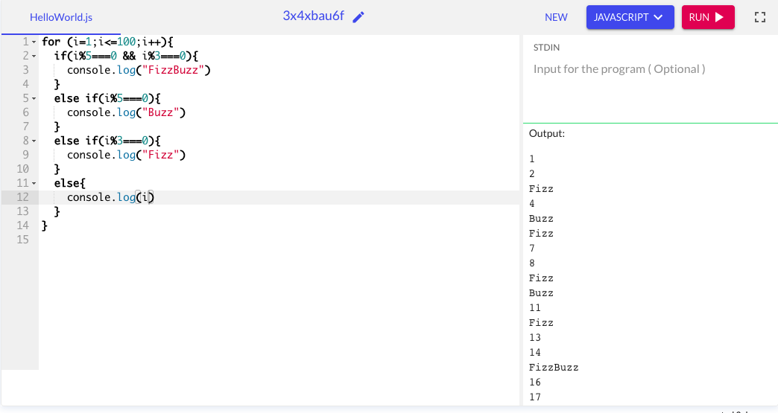

Caption

Ques 2:

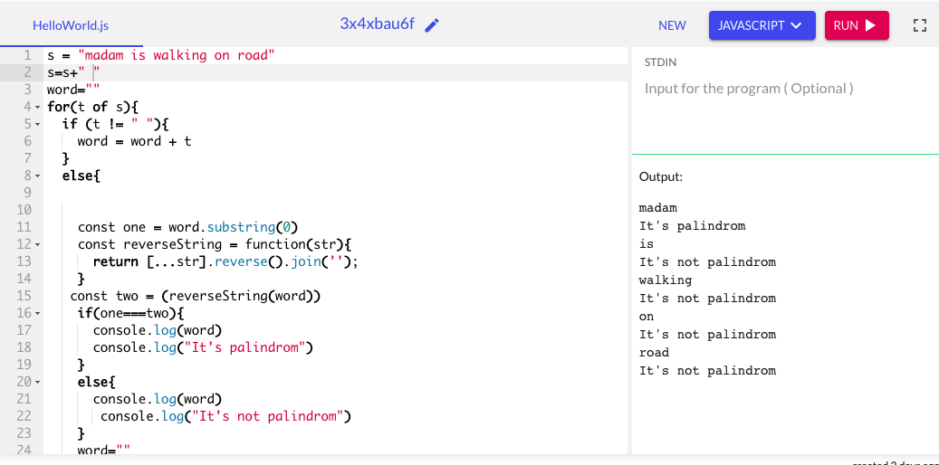

Caption